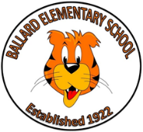  **Ballard Elementary**

**Uniform Requirements**

**Tops**

1. Polo style shirt with a collar.
2. Can be short or long sleeved.
3. Plain Tee Shirts.

School Uniform Colors: Light Blue, White, Navy Blue, Hunter Green, Red

**Bottoms**

Boys- Pants or Shorts

Girls-Pants, shorts, skirts, skorts, dresses or jumpers.

(Uniform bottoms must not be shorter than above the tips of the fingers, with arms and hands extended straight down.

Colors for uniform Bottoms; Navy Blue or Khaki

**Outerwear**

Jackets, sweaters and sweatshirts can be worn.

Solid uniform colors preferred-

Light Blue, White, Navy Blue, Hunter Green, Red

**Shoes**

Sneakers or closed toed shoes are preferred. Shoes must have a back strap, no heels.

**Tuesday**

Children may wear their House Shirt with their uniform bottoms.

**Friday**

Any Ballard School t-shirt and a hat may be worn.

(ie: track, TSA, FSA University)

Denim is also allowed on Fridays but no other day of the week.